**Leadership & Safety  
Calendar**  
2016 - 2017

**Safe to Learn Community Project 2016-2017 ©**

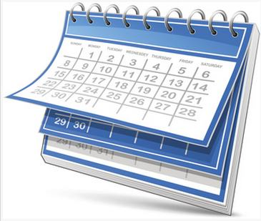



The goal of *Safe to Learn* is to always remain a community of caring people with the same mission and commitment: Provide what is best for all children and keep them safe so they will be able to learn.

Year Round Leadership & Safety The 2016-2017 **Safe to Learn Leadership & Safety Calendar** includes links to many nationally recognized Health and Safety events. Each year we will be updating the calendar and also adding events as they are submitted to Safe to Learn.   
  
  
  
Submit Suggested Events or resources:  
  
Email: [dee.beaugez@viplanning.com](mailto:dee.beaugez@viplanning.com)

**2016 Safe to Learn© Creative Team**

Editor – Elizabeth Hall  
Designer – Jessika Savage, BFA  
Creative Director – Dee Beaugez, MA

Table of Contents

Year Round Leadership & Safety 2

Plan Ahead for School Events 5

Summer Planning Resources 7

Elementary School Resources 9

Elementary School Resources – Page 2 11

MS & JH School Resources 13

High School Resources 17

High School Resources, page 2 Library Resources 18

⇨ Education World References 18

o Article “I Was There When High School Research Papers Came Alive!” http://www.educationworld.com/a_curr/curr368.shtml 18

o *** Voice of Experience Each week, an educator takes a stand or shares an Aha! classroom moment in the Education World Voice of Experience column. http://www.educationworld.com/a_curr/archives/voice.shtml 18

▪ Three Differences Between Teaching and Administration *Time – Student Contact - Scope* http://www.educationworld.com/a_curr/voice/voice114.shtml 18

2016 Calendar 20

Make sure your *Safety Plan* includes all special needs students 21

Special Needs Resources 22

RESOURCE Learn more about the benefits of sign language from Nancy Hanauer, Founder of Hop to Signaroo ® 26

September Event Links 27

Provide Students with Tools to Keep Them Safe in Any Situation 29

October Event Links 30

October 2016 Calendar 31

November Event Links 33

November 2016 Calendar 34

December Event Links 35

December 2016 Calendar 36

2017 Calendar 37

January Event Links 38

January 2017 Calendar 39

February Event Links 40

February 2017 Calendar 41

March Event Links, page 2 43

March 2017 Calendar 44

April Event Links – Page 2 National Week of the Ocean (1st week) School Library Month National Library Week (8-14) International Children's Book Day (1st Wed of April) 46

April 2017 Calendar 47

May Event Links 48

May Event Links, page 2 49

May 2017 Calendar 50

June Event Links, page 2 52

June Calendar 2017 53

July Event Links 54

July Calendar 2017 55

August Event Links 56

August Calendar 2017 57

Other Safety Resources 59

Event Links & Resources 61

Research Links 62

About School Planning 63

Working Together Supporting School Safety 64

# Plan Ahead for School Events

**Start planning in August future events**

* **National School Bus Safety Month is in October  
  Remember that posters must arrive by October 1, 2016 Contest**
  + **2016 Theme: # STOP ON RED!**   
    All posters must be received at BNAPT Headquarters by October 1, 2016  
    National School Bus Safety Poster Contest  
    c/o NAPT: 1840 Western Ave., Albany, NY 12203
    - **Poster Rules** <http://www.napt.org/files/2014PosterRules.pdf>   
      **2016 Contest Page**<http://napt.org/resources/national-school-bus-safety-week.php>   
      &
    - **Resource Guide and Activity Book**[1]  
      <http://naptonline.org/files/NSBSWdoc_Color.pdf>
* **Fire Prevention Resources - Stop, Drop, Roll, Cool & Call** <http://burnprevention.org/programs-services/childrens-fire-safety-burn-prevention/stop-drop-roll-cool-call/>
* **National Fire Prevention Week is in October  
  Contact Local Fire Department** and ask if they arethey hosting any events   
  for National Fire Prevention Week in October?  
  + **NFPA Education Programs: Sparky School House** (K- 3rd Grade)  
    <http://sparkyschoolhouse.org/>

[Camp Susquehanna](http://burnprevention.org/camp-susquehanna/about/)  
Camp is a 4 day, sleep-away experience for children ages 7-17 who have had a burn injury.  
 It is an opportunity for children to have fun, learn life skills, and meet other burn survivors.  
 *Lancaster County, Pennsylvania*

*June 2016*

* + **Public Education – Safety Tips Page**<http://www.nfpa.org/public-education/resources/safety-tip-sheets>
  + **Burn Prevention Network – Teacher’s Corner**<http://burnprevention.org/programs-services/teachers-corner/>
    - **Burn Prevention Network** <http://burnprevention.org/>
  + **Children’s Fire Safety & Burn Preventing Information**<http://burnprevention.org/programs-services/childrens-fire-safety-burn-prevention/>
* **Walk Bike to School Day is in October** 
  + **Event Planning Tips:**<http://www.walkbiketoschool.org/get-set/plan-the-event/planning-a-biketoschool-event>
  + **First-Time Tips:**<http://www.walkbiketoschool.org/get-set/plan-the-event/first-time-tips>
  + **Plan an Event in 7 Days**  
    <http://www.walkbiketoschool.org/get-set/plan-the-event/plan-event-in-7-days>
  + **Talking Points**<http://www.walkbiketoschool.org/get-set/promote-the-event/talking-points>
    - **Walk to School**<http://www.walkbiketoschool.org/sites/default/files/WTSD-Talking-Points-2013.pdf>   
      Includes fuel costs data!
    - **Bike to School**<http://www.walkbiketoschool.org/sites/default/files/BTSD%20Talking%20Points-2014_0.pdf>
  + **Involve the Principal**<http://www.walkbiketoschool.org/get-set/involve-the-community/school-principal>
  + *Study by Centers for Disease Control & Prevention (84-page PDF)* **“The Association Between School-Based Physical Activity, Including Physical education and Academic Performance”**<http://www.cdc.gov/healthyyouth/health_and_academics/pdf/pa-pe_paper.pdf>
  + **Involve the Community**<http://www.walkbiketoschool.org/get-set/involve-the-community>

# Summer Planning Resources

Plan in June for July Fireworks & Burn Prevention

* **Fireworks Safety is in July – information could be included in June**
  + **The National Council in Fire Works**   
    <http://fireworkssafety.org/>   
    & <http://www.fireworkssafety.org/safety-tips/>
    - **Posters for Safety Including Safe Fireworks Disposal & Sparkler Safety** <http://www.fireworkssafety.org/safety-store/>

Working Smoke Alarms reduce the chances of dying in a fire by nearly 50 percent!

* **US Fire Administration**  
  <https://www.usfa.fema.gov/prevention/>
* **\*\*\*\*\*Sesame Street Fire Safety Program**<https://www.usfa.fema.gov/prevention/outreach/ss_safety_program.html>
  + **US Consumer Product Safety Commission**  
    <http://www.cpsc.gov/Safety-Education/Safety-Education-Centers/Fireworks/>   
    &
  + **Sparklers Can Burn - Poster**  
    <http://www.cpsc.gov/en/Safety-Education/Neighborhood-Safety-Network/Posters/Sparklers-can-Burn-at-2000-Degrees-Fahrenheit/>   
    &
  + **Burn Prevention Network - Summer Information Links**  
    <http://www.burnprevention.org/>   
    &
  + **Fire Prevention for Big Kids (5-9 years)**<http://www.safekids.org/safetytips/field_age/big-kids-5%E2%80%939-years/field_risks/fire/field_type/activities-kids>   
    &
  + **Fire Safety for Pre-Teens (10-14 years)**<http://www.safekids.org/safetytips/field_age/pre-teens-10-14/field_risks/fire/field_type/activities-kids>   
    &
  + **Fire & Burn Safety For Teens (15-19 years)**<http://www.safekids.org/safetytips/field_age/teens-15%E2%80%9319-years/field_risks/fire/field_type/activities-kids>

&

* + **\*\*\*Fire Safety Facts**<http://www.safekids.org/safetytips/field_age/special-needs/field_risks/fire/field_type/activities-kids>
  + **Burn Prevention for Teens**<http://www.safekids.org/safetytips/field_age/teens-15–19-years/field_risks/burns-and-scalds>
  + **Burn & Scalds Prevention Tips**<http://www.safekids.org/tip/burns-and-scalds-prevention-tips>
  + **More Tips about Preventing Burns & Scalds**<http://www.safekids.org/safetytips/field_risks/burns-and-scalds>

**Have your children learn CPR.**   
It’s a skill that will serve them   
for a lifetime.

Swimming Safety Tips

* **Safety Tips for Teens**  
  <http://www.safekids.org/safetytips/field_age/teens-15%E2%80%9319-years/field_risks/swimming-and-water>
* **Tips for Swimming & Boating Safety**<http://www.safekids.org/other-resource/useful-links-swimming-and-boating-safety>
* **How to Avoid Getting Caught in a Rip Current (National weather Service)**<http://www.ripcurrents.noaa.gov/>
  + Texas Sea Grant - Online Survey  
    <http://today.tamu.edu/2015/06/04/rip-current-survey-could-save-lives/>
  + Break the Grip of The Rip (US Army Corps of Engineers)  
    <http://www.nws.noaa.gov/training/BreaktheGripoftheRip/player.html>
  + IF YOU ARE CAUGHT IN A RIP (graphic)  
    <http://www.nws.noaa.gov/training/BreaktheGripoftheRip/player.html>
  + How to escape a Rip Current #1  
    <http://www.nws.noaa.gov/training/BreaktheGripoftheRip/player.html>
  + How to escape a Rip Current #2  
    <http://www.nws.noaa.gov/training/BreaktheGripoftheRip/player.html>

# Elementary School Resources

**Hand Washing**

* **Handwashing Lessons Plans & Resources***Center for Disease Control and Prevention (CDC)*  
  **Classroom Lessons & Activates**<http://www.cdc.gov/handwashing/training-education.html>
* **December is National Hand Washing Month   
  Hand Washing Experiment (Grades 5-8)**<https://www.cdc.gov/bam/teachers/documents/epi_4_hand_wash.pdf>
* **Glo Germ Grades (K-6)** **= Educational Worksheets**  
  <http://www.glogerm.com/worksheets.html>

**Nutrition**

* **School Meal Trends & Stats**<https://schoolnutrition.org/AboutSchoolMeals/SchoolMealTrendsStats/>
* **More than Just Lunch**<https://schoolnutrition.org/AboutSchoolMeals/MoreThanJustLunch/>
* **School Lunch Hero Day (May 5, 2017)**<http://www.schoollunchheroday.com/downloads.html>
  + **Stories of Lunch Heroes**<http://www.schoollunchheroday.com/slhdstories.html>

**\*\* Free Coloring Books (K-Elementary)**<http://www.first-school.ws/theme/educational-resources/free-coloring-books-online.htm>  **PDF** <http://extension.illinois.edu/foodfun/downloads/book.pdf>

* **Super Kids Nutrition + Coloring Pages**<http://www.superkidsnutrition.com/nutrition_resources/nutritioncurriculum/>
* **Food Printable Worksheets  
  Nourish Interactive**<http://www.nourishinteractive.com/nutrition-education-printables>
* **Meal Planners by Age** (2 to 9 years)  
  <http://www.nourishinteractive.com/nutrition-education-printables/category/16-printable-kids-healthy-menu-plans-daily-meal-planner-childrens-healthy-food-groups-balanced-meals>

***Elementary School Resources, Page 2***

**School Bus Safety**

* **School Bus Safety Reminders – 10 Points (Printable PDF)**<http://www.scholastic.com/parents/resources/free-printable/more-printables/school-bus-safety-printable-poster>

**Fire Prevention**

* **October is National Fire Prevention Week  
  Sparky the Fire Dog web site – October**<http://www.sparky.org/>   
  &  
  **Where Safety Connects with Learning**

*Teach Fire Safety and Save Lives*  
<http://sparkyschoolhouse.org/>   
&  
**Home Fire Drills – featuring Help Mikey Make it Out**Video –Interactive Q&A  
<http://www.homefiredrill.org/Mikey/mikeygame.html>  
&  
**Stop, Drop, Roll, Cool & Call – Burn Prevention Network**<http://www.burnprevention.org/programs-services/childrens-fire-safety-burn-prevention/stop-drop-roll-cool-call>

**Library Month**

* **December is School Library Month**   
  Link to Videos of winners of “Lives Change @ Your Library”  
  Features winners from high schools, middle schools and elementary schools  
  <http://www.ala.org/aasl/slm/2014/video>
* **Libraries Transform Communities**<http://www.ala.org/news/mediapresscenter/presskits/ltc>
* **Resources for School Librarians**  
  A Directory of Lesson Plans for Information Skills Instructions  
  <http://www.sldirectory.com/libsf/resf/libplans.html>

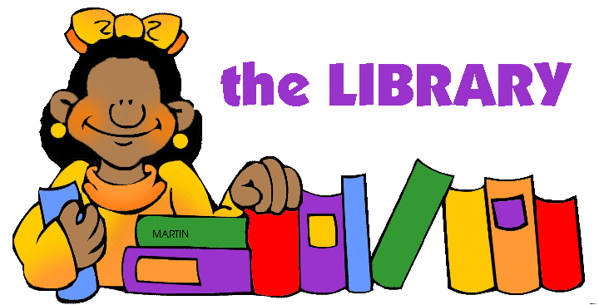

© Graphic by Phillip Martin

## Elementary School Resources – Page 2

* **February is Burn Awareness Week** 
  + **Home Fire Drill Resources***This September remember to change your clock, update emergency supplies, pick a spot to meet and practice a fire drill*<http://www.homefiredrill.org/>   
    &
  + **Help Mikey Make it Out***Interactive animation*  
    <http://www.homefiredrill.org/Mikey/mikeygame.html>  
    &
  + **Fire, Burns and Scalds Prevention**  
    <http://www.safekids.org/fires-burns-and-scalds-prevention>
    - Burn Safety Fact Sheet  
      <http://www.safekids.org/fact-sheet/burns-and-fire-safety-fact-sheet-2015-pdf>
    - More Safety Fact Sheets   
      <http://www.safekids.org/listing/fact-sheet>
* **March is Learning Disabilities Month**   
  Books for children  
  <http://www.ldonline.org/kids/books>  
  Ages 9-12 <http://www.ldonline.org/kids/books/onlyone>   
  Ages 9- 12 and Teens <http://www.ldonline.org/kids/books/ld>   
  Ages 3 - 12 <http://www.ldonline.org/kids/books/expressing>   
  Ages 3- 12 and Teens <http://www.ldonline.org/kids/books/friends>
* **March is Poison Prevention Week**Child Tips   
  <http://poisonhelp.hrsa.gov/what-can-you-do/prevention-tips/child-tips/index.html>

1 (800) 222-1222

American Association of Poison Control Centers

Hours: 24 hours, 7 days a week

Languages: English

Website: [www.aapcc.org](http://www.aapcc.org/)



**April is School Library Month**

* **April is School Library Month   
  2016 Theme – School Libraries Transform Learning**<http://www.ala.org/aasl/slm>  
  History <http://www.ala.org/aasl/slm/history>   
    
  The theme of the first national observance of School Library Month in 1985 was "Where Learning Never Ends: The School Library Media Center."
* “**School Libraries Transform Learning.”  
  2016 Spokesperson Megan McDonlad**<http://www.ala.org/aasl/slm/2016/psa>   
    
  “I would not be who I am without the early impact of my school library and librarian. I grew up to become a librarian. I grew up to become a storyteller. I grew up to become a writer. School librarians not only foster a lifelong love of reading and story, they encourage thinking and creativity. They support curious minds. They inspire young imaginations. School librarians shape lives.”
* **\*\* American Association of School Librarians (AASL)**Best Websites for Teaching and Learning  
  <http://www.ala.org/aasl/standards/best/websites/2015>   
    
  The 2015 Best Websites for Teaching & Learning foster the qualities of innovation, creativity, active participation, and collaboration. They are free, Web-based sites that are user friendly and encourage a community of learners to explore and discover.   
  [Media Sharing](http://www.ala.org/aasl/standards/best/websites/2015#media) | [Digital Storytelling](http://www.ala.org/aasl/standards/best/websites/2015#storytelling) | [Manage & Organize](http://www.ala.org/aasl/standards/best/websites/2015#manage) |   
  [Social Networking & Communication](http://www.ala.org/aasl/standards/best/websites/2015#social) | [Content Resources](http://www.ala.org/aasl/standards/best/websites/2015#resources) |  
  [Curriculum Collaboration](http://www.ala.org/aasl/standards/best/websites/2015#curriculum)
* **My Storybook**  
  Welcome to our Community to Storytellers  
  <https://www.mystorybook.com/>

# MS & JH School Resources

* **Drunk Driving**  
  About Drunk Driving, MADD’s Annual Campaign, Information by State  
  <http://www.madd.org/drunk-driving/>
* **Suicide Prevent Programs for Teens and Young Adults**  
  American Foundation for Suicide Prevention  
  <https://www.afsp.org/preventing-suicide/our-education-and-prevention-programs/programs-for-teens-and-young-adults>
* **October is Fire Prevention Week  
  The Great Escape (Grades 6-8)**  
  <http://www.burnprevention.org/programs-services/childrens-fire-safety-burn-prevention/great-escape>
* **December is School Library Month 2014**   
  Link to Videos of winners of “Lives Change @ Your Library”  
  Features winners from high schools, middle schools and elementary schools  
  <http://www.ala.org/aasl/slm/2014/video>
* **December is National Hand Washing Month**[CDC Science Ambassador Lesson Plans – Inquiry into Infectious Disease: It’s a Germy World After All](http://www.cdc.gov/excite/ScienceAmbassador/ambassador_pgm/lessonplans_germs.htm) (9-12)   
  This lesson engages high school students in a demonstration of how germs are transmitted from person to person and involves them in an inquiry-based activity and webquest.
* **March is Poison Prevention Week**Child Tips   
  <http://poisonhelp.hrsa.gov/what-can-you-do/prevention-tips/child-tips/index.html>

1 (800) 222-1222

American Association of Poison Control Centers

Hours: 24 hours, 7 days a week

Languages: English

Website: [www.aapcc.org](http://www.aapcc.org/)

*Middle School & Junior High School, page 2*

* **April is School Library Month**<http://www.ala.org/aasl/slm>  
  History <http://www.ala.org/aasl/slm/history>
* **\*\* American Association of School Librarians (AASL)**Best Websites for Teaching and Learning  
  <http://www.ala.org/aasl/standards/best/websites/2015>   
    
  The 2015 Best Websites for Teaching & Learning foster the qualities of innovation, creativity, active participation, and collaboration. They are free, Web-based sites that are user friendly and encourage a community of learners to explore and discover.   
  [Media Sharing](http://www.ala.org/aasl/standards/best/websites/2015#media) | [Digital Storytelling](http://www.ala.org/aasl/standards/best/websites/2015#storytelling) | [Manage & Organize](http://www.ala.org/aasl/standards/best/websites/2015#manage) |   
  [Social Networking & Communication](http://www.ala.org/aasl/standards/best/websites/2015#social) | [Content Resources](http://www.ala.org/aasl/standards/best/websites/2015#resources) |  
  [Curriculum Collaboration](http://www.ala.org/aasl/standards/best/websites/2015#curriculum)
* **My Storybook**  
  Welcome to our Community to Storytellers  
  <https://www.mystorybook.com/>
* **Resources for School Librarians**  
  A Directory of Lesson Plans for Information Skills Instructions  
  <http://www.sldirectory.com/libsf/resf/libplans.html>

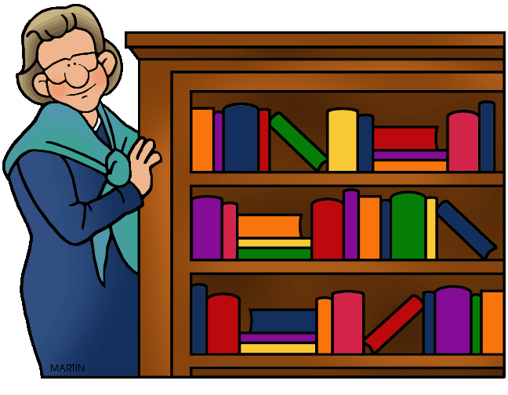

© Graphic by Phillip Martin

*Middle School & Junior High School, page 3*

**HIV Awareness Resources**

* **HIV Among Youth Information and Statistics***Centers for Disease Control and Prevention (CDC)*In 2014, youth aged 13 to 24 accounted for an estimated 22% of all new HIV diagnoses in the United States.<http://www.cdc.gov/hiv/risk/age/youth/index.html>
* **April is HIV Awareness Days**Centers for Disease Control and Prevention (CDC) participates in national HIV/AIDS Awareness Days in order to raise awareness of HIV <http://www.cdc.gov/hiv/library/socialmedia/awarenessdays.html>
* **Youth HIV/AIDS Awareness Day – April 10th**  
  National Youth HIV/AIDS Awareness Day is observed each year on April 10 to educate the public about the impact of HIV and AIDS on young people and to highlight the work young people are doing across the country to respond to the epidemic.<http://www.cdc.gov/hiv/library/awareness/nyhaad.html>
* **Advocates for Youth**<http://www.advocatesforyouth.org/nyhaad-partners>

**Children’s Mental Health Awareness**

* **National Children’s Mental Health Awareness Day is Celebrated in May each year.** <http://www.samhsa.gov/children/national-events>   
    
  National Children’s Mental Health Awareness Day seeks to raise awareness about the importance of children’s mental health and to show that positive mental health is essential to a child’s healthy development from birth.   
  (Background: [May 5, 2016 event](http://www.samhsa.gov/children/national-childrens-awareness-day-events/awareness-day-2016))
* **Safe Schools/Healthy Students (SS/HS) Resources**<http://www.samhsa.gov/safe-schools-healthy-students>  
  + **Suicide Prevention and Post-Suicide Coping Resources**<http://www.samhsa.gov/safe-schools-healthy-students/resources/suicide-prevention>

*Middle School & Junior High School, page 4*

* **NASP – National Association of School Psychologists  
  School Safety & Crisis**<http://www.nasponline.org/resources-and-publications/resources/school-safety-and-crisis>   
  + **Preventing Youth Suicide – Brief Facts and Tips**<http://www.nasponline.org/resources-and-publications/resources/school-safety-and-crisis/preventing-youth-suicide>
* **Preventing Youth Suicides**  
  <http://www.nasponline.org/resources-and-publications/resources/school-safety-and-crisis/preventing-youth-suicide>

**National Suicide Prevention Lifeline at 1-800-273-TALK (8255)**

* **Threat Assessment at School – Brief Facts & Tips**  
  <http://www.nasponline.org/resources-and-publications/resources/school-safety-and-crisis/threat-assessment-at-school>
* **School Violence Prevention – Brief Facts and Tips**<http://www.nasponline.org/resources-and-publications/resources/school-safety-and-crisis/school-violence-prevention>   
    
    
  **Other Resources**
* **Trevor Project for Youth**   
  <http://www.thetrevorproject.org/>
* **American Foundation for Suicide Prevention**  
  <https://afsp.org/>
  + About Suicide  
    <https://afsp.org/about-suicide/>
  + Suicide Statistics  
    <https://afsp.org/about-suicide/suicide-statistics/>

High School Resources

* **Drunk Driving**  
  About Drunk Driving, MADD’s Annual Campaign, Information by State  
  <http://www.madd.org/drunk-driving/>
* **National Teen Driver Safety Campaign - Sample Campaign***Ride Like A Friend. Drive Like You Care (RLAF)*October National Event (October 16-22, 2016)  
  <http://www.teendriversource.org/more_pages/page/try_this_teen-to-teen_campaign_at_your_school/teen>
* **About AFSP’s Suicide Prevent Programs**   
  American Foundation for Suicide Prevention  
  <https://afsp.org/about-suicide/>
* **CDC Science Ambassador Lesson Plan  
  Inquiry into Infectious Diseases**  
  <http://www.cdc.gov/excite/ScienceAmbassador/ambassador_pgm/lessonplans_germs.htm>   
  **\*\*\* HS Lessons Plans – Germs (Page Links to Lessons Plan PDF)**  
  <http://www.cdc.gov/excite/ScienceAmbassador/ambassador_pgm/lessonplans/Germy-World.pdf>   
  &  
  **CDC Handwashing: Clean Hands Save Lives (Training & Education)**<http://www.cdc.gov/handwashing/training-education.html>
* **April is School Library Month**   
  Link to Videos of winners of “Lives Change @ Your Library”  
  Features winners from high schools, middle schools and elementary schools  
  <http://www.ala.org/aasl/slm/2014/video>
* **March is Poison Prevention Week (Teen Tips)**<http://poisonhelp.hrsa.gov/what-can-you-do/prevention-tips/teen-tips/index.html> \  
  **Get ready for 2015 *National Poison Prevention Week*, March 19-25, 2017**<http://poisonhelp.hrsa.gov/what-can-you-do/national-poison-prevention-week/index.html>

1 (800) 222-1222

American Association of Poison Control Centers

Hours: 24 hours, 7 days a week - Languages: English Website: [www.aapcc.org](http://www.aapcc.org/)

## High School Resources, page 2 Library Resources

"A teacher affects eternity;   
he can never tell where his influence stops." ~ Henry Adams

* **April is School Library Month**<http://www.ala.org/aasl/slm>
  + **History**<https://www.ala.org/aasl/slm/history> **Resources for School Librarians**  
    A Directory of Lesson Plans for Information Skills Instructions  
    <http://www.sldirectory.com/libsf/resf/libplans.html>

**Articles, Ideas and Experience**

## Education World References

## Article “I Was There When High School Research Papers Came Alive!” <http://www.educationworld.com/a_curr/curr368.shtml>

## *** Voice of Experience Each week, an educator takes a stand or shares an Aha! classroom moment in the Education World Voice of Experience column. <http://www.educationworld.com/a_curr/archives/voice.shtml>

## Three Differences Between Teaching and Administration *Time – Student Contact - Scope* <http://www.educationworld.com/a_curr/voice/voice114.shtml>

* + - **Advice for Budding Teachers: Five questions to Consider**<http://www.educationworld.com/a_curr/voice/voice137.shtml>
    - **Taming the Three Ts***Thought, Temper and Tongue*<http://www.educationworld.com/a_curr/voice/voice098.shtml>

**Noted educator, Haim Ginott said it best:**   
"I've come to the frightening conclusion that I am the decisive element in the classroom. It's my personal approach that creates the climate. It's my daily mood that makes the weather. As a teacher, I possess tremendous power to make a child's life miserable or joyous. I can be a tool of torture or an instrument of inspiration. I can humiliate or humor, hurt or heal. In all situations, it is my response that decides whether a crisis will be escalated or de-escalated and a child humanized or de-humanized."

**High School Resources, page 3**

**Earth Day**

* **Earth Day is in April each year**<http://www.earthday.org/earth-day/>   
  &
* **History of Earth Day**<http://www.earthday.org/about/the-history-of-earth-day/>

**&**

* **Tool Kit**<http://www.earthday.org/earth-day/earth-day-toolkit/>   
    
    
  Add your favorite Earth Day Links
* **________________________________________________**
* **________________________________________________**
* **________________________________________________**
* **________________________________________________**
* **________________________________________________**
* **________________________________________________**

# 2016 Calendar

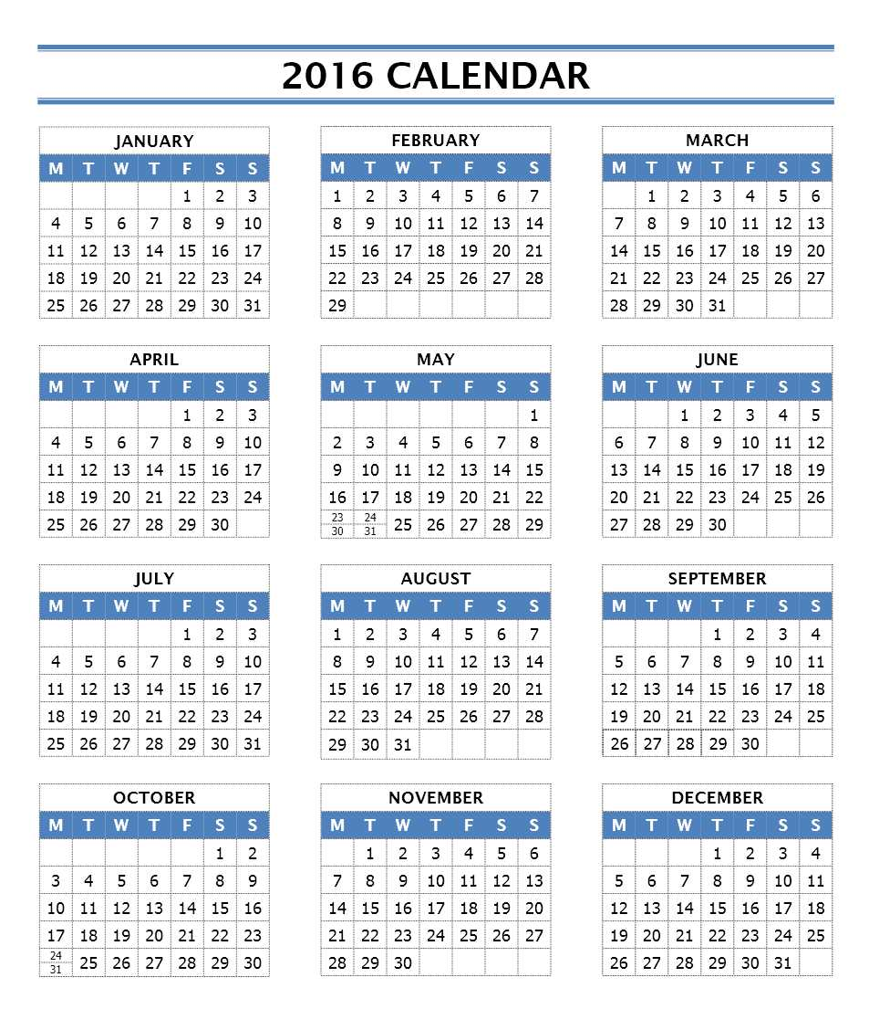

## Make sure your *Safety Plan* includes all special needs students

*C:\Documents and Settings\deb\Local Settings\Temporary Internet Files\Content.IE5\CRW1FBH1\MC900021514[1].wmf*“Whatever Emergency Plan you choose, make sure it includes provisions for your special needs students and an accurate attendance accounting so you know if any missing students are really absent and not still in the building.  Have people in your building assigned to certain accountability jobs to make sure that the building is cleared and   
the proper authorities are notified.”  
*Principal Kelly Waters   
George Junior High School  
Lamar CISD - Texas*  
 **10 Things Teachers Should Know About Servicing Students with Special Needs**

1. _____________________________________________
2. _____________________________________________
3. _____________________________________________
4. _____________________________________________
5. _____________________________________________
6. _____________________________________________
7. _____________________________________________
8. _____________________________________________
9. _____________________________________________
10. ______________________________________________

**Resource: WE are TEACHERS**  
**Special Education** <http://www.weareteachers.com/lessons-resources/special-education>

# Special Needs Resources

* **Center for Parent Information and Resources**
  + **Special Needs - Disability (Links and Articles)**  
     <http://www.parentcenterhub.org/topics/disability/>
  + **Better Hearing and Speech Month (May)**Each May, the American Speech-Language-Hearing Association (ASHA) highlights Better Hearing & Speech Month (BHSM) to raise awareness about communication disorders. The 2015 theme is “Early Intervention Counts.” Results of a recent survey of ASHA’s membership revealed that 45% of expert respondents reported lack of awareness as the #1 barrier to early detection of communication disorders.  
    <http://www.parentcenterhub.org/repository/may2015-asha/>
    - ASHA Link - 2016 theme was "Communication Takes Care"   
       <http://www.asha.org/BHSM/>
    - John Hopkins Medicine: Better Hearing and Speech Month <http://www.hopkinsmedicine.org/health/awareness/hearing_speech_month.html>
  + **\*\*\*\*A Teen’s Guide to Autism***Video in English – narrator is also a teen, plus video in Spanish*Created by Alexandra Jackman of Westfield, NJ, the purpose of this   
    14-minute documentary, released in 2013, is to help teenagers be more aware and understanding of people with Autism Spectrum Disorder (ASD). It has also been translated to Spanish.  
    <http://www.parentcenterhub.org/repository/a-teens-guide-to-autism/>
  + **School Planning and Educational Strategies Following   
    Traumatic Brain Injury** (Webinar and download handouts) <http://www.parentcenterhub.org/repository/webinar-tbi-2014/>
  + **A Special Needs Pre-Flight checklist: 16 things you need to do before heading to the Airport.**<http://www.friendshipcircle.org/blog/2012/01/09/a-special-needs-pre-flight-checklist/>   
    - **Air Travel: 5 Books to help prepare your child for travel**While not specifically written for children with special needs these books do a great job to prepare an anxious child for flying and making sure they understand what to expect and what is appropriate while flying. <http://www.friendshipcircle.org/blog/2011/12/05/airplane-travel-5-books-to-help-prepare-your-special-needs-child/>

*Special Needs Resources, Page 2*

* + - **Air Travel: 5 Books to help prepare your child for travel, Continued,**
      * **The Noisy Airplane Ride** by Mike Downs – Illustrator David Gordon
      * **Going on a Plane** by Anne Civardi – Illustrator Stephen Cartwright
      * **Airport**Author/Illustrator Byron Barton (Ages 3 to 6)
      * **Amazing Airplane**Author Tony Mitton – Illustrator Ant Parker (Ages 3 to 5)
      * **All Aboard Airplanes**Author Frank Evans – Illustrator George Guzzi
* **YouTube Videos: Autism and Asperger for Educators**
  + **A Teen’s Guide to Autism**<https://www.youtube.com/watch?v=p9-l19CKISg&feature=youtu.be>
  + **Essentials for Educators: High Functioning Autism   
    & Asperger Syndrome**  
    <https://www.youtube.com/watch?v=_S35NDMuoJ4>
  + **Understanding Autism: A Guide for Secondary School Teachers (Part 1)** <https://www.youtube.com/watch?v=4yAAOI6JUsM>
    - **(Part 2) Integrating Supports in the Classroom** <https://www.youtube.com/watch?v=veQKDDE9C_w>
    - **(Part 3) Practices for Challenging Behavior**<https://www.youtube.com/watch?v=LK5Pr9h10BY>
    - **(Part 4) Effective Use of Teacher Supports**<https://www.youtube.com/watch?v=X4GdaD2Izxc>
* **Education Week**
  + **By the Numbers> Students with Disabilities** *(May 2015)**Hearing Impairment;**Emotional Disturbance; Specific Learning Disability; Autism; Intellectual Disability;* <http://www.edweek.org/ew/dc/2015/by-the-numbers-students-with-disabilities.html>
  + **Next Steps**: **Life After Special Education  
    Diplomas Count 2015: Report and Graduation Rates**  
    <http://www.edweek.org/ew/toc/2015/06/04/index.html>
    - **Experience Is Key for Special Ed Students   
      Headed to the workplace**<http://www.edweek.org/ew/articles/2015/06/04/experience-is-key-for-special-ed-students.html?intc=EW-DPCT15-TOC>

**RESOURCE**  
Links to Phillip Martin's FREE   
Clip Art for Educators

The Clip Art from Phillip Martin's website (links listed below) is Free for teachers  
to use in their classrooms for student worksheets, on blogs and websites, and  
​other NON-COMMERCIAL uses.  
  
The Classroom Presentations in PowerPoint format are for teacher use only and are not permitted to be put on any other site. <http://www.phillipmartin.info/clipart/terms.htm>  
  
School Clip Art for Teachers & Educators  
<http://school.phillipmartin.info/index_school.htm>  
© Graphics by Phillip Martin

* Animals   
  <http://animals.phillipmartin.info/index_animals.htm>
* Holidays  
  [www.directories.phillipmartin.info/home_holidays.htm](http://www.directories.phillipmartin.info/home_holidays.htm)
* Language Arts  
  <http://directories.phillipmartin.info/home_language_arts.htm>
* Math  
  <http://math.phillipmartin.info/index_math.htm>
* People   
  <http://directories.phillipmartin.info/home_people.htm>
* Science  
  <http://directories.phillipmartin.info/home_science.htm>
* Social Sciences  
  <http://directories.phillipmartin.info/home_social_sciences.htm>
* Sports  
  <http://sports.phillipmartin.info/index_sports.htm>
* Travel the World  
  [www.phillipmartin.info/webpage/travel/text_map_globe.htm](http://www.phillipmartin.info/webpage/travel/text_map_globe.htm)
* Other Things  
  <http://www.directories.phillipmartin.info/home_other_things.htm>

Terms of Use for Philip Martin Clip Art - (Free Use for Teachers & Educators)   
The artwork contained on Philip Martin's website are original works created by Phillip Martin and are protected by the U.S. Copyright Act of 1976 and other laws. The artwork contained on this website are original works created by Phillip Martin and are protected by the U.S. Copyright Act of 1976 and other laws.  
<http://www.phillipmartin.info/clipart/terms.htm>

**About Phillip Martin** <http://www.safetolearn.com/artist-phillip-martin.html>

Look for Author Phillip Martin’s “The Mural Man Series”  
 <http://www.safetolearn.com/-phillip-martin---the-mural-man.html>   
& A Taste of My World Cookbook” Series   
<http://www.safetolearn.com/a-taste-of-my-world-cookbooks-by-phillip-martin.html>

**RESOURCE**  
Sing With Our Kids, Nancy Stewart's Pilot Project and Free Resources   
“One day I realized many of our children were no longer singing, in their schools, on the playgrounds, or with their families. Why does it matter? Because we are literally wired to sing, and when we do, our children naturally gain countless skills and qualities they need to fully develop. Singing is free and is something everyone can do.   
  
I created Sing With Our Kids to provide everyone, regardless of income or education, the resources to take advantage of this natural ability we all already have.”  
~ Nancy Stewart, Founder of Sing With Our Kids  
  
The free resources on SingWithOurKids.com empower families, parents, teachers, and their communities to support early learning by simply singing together. Because Sing With Our Kids is also an ongoing pilot project, resources are being constantly updated to reflect changes in our communities and new information provided by the most current research.  
  
Information for this page is provided by Nancy Stewart, Founder of Sing With Our Kids   
<http://www.safetolearn.com/lets-sing.html>   
  
  
**Why Sing?**  
We are literally wired to sing, from before birth. And when we do, here are just a few of the things that happen.

* When we sing together we instantly connect, building empathy and understanding of each other
* When we sing we are comforted, and our children feel safe and cared for
* When we sing with our children it helps build all the skills they need to be ready to read <http://singwithourkids.com/info-reading-skils.htm>
* Singing finger plays, like The Itsy Bitsy Spider, helps children develop fine motor skills.
* Singing game like Ring Around the Rosy help develop gross motor skills.

To learn more about how you can use these resources, visit [www.SingWithOurKids.com](http://www.singwithourkids.com/)

**Read more about how Music Powers the Brain; Music Influences Us; Music Connects Us; and Music Comforts Us.**[nancymusic.com/music-why-sing.htm](http://nancymusic.com/music-why-sing.htm)

* Singing and Early Learning Skills [nancymusic.com/music-reading-skills.htm](http://nancymusic.com/music-reading-skills.htm)
* Singing and Language Acquisition nancymusic.com/music-connection.htm

RESOURCE  
Learn more about the benefits of sign language from Nancy Hanauer, Founder of Hop to Signaroo ®   
  
With 20+ years of teaching and signing experience, her passion for teaching and American Sign Language has taken her career in many unique directions, often bridging the gap between the deaf and hearing communities.

* [Teacher Nancy Hanauer, Founder of Hop to Signaroo ®](http://www.safetolearn.com/nancy-hanauer-founder-hop-to-signaroo-reg.html)
* [Yes, Babies Can Communicate Before They Speak!](http://www.safetolearn.com/babies-can-communicate.html)
* [American Sign Language Can Benefit All Children as They Develop Social and Learning Skills](http://www.safetolearn.com/signing-for-social-and-learning-skills.html)
* [www.hoptosignaroo.com](http://www.hoptosignaroo.com/)

American Sign Language (ASL) Resources

* [Signing Savvy Online Dictionary](https://www.signingsavvy.com/) Signing Savvy is a sign language dictionary containing video versions of American Sign Language (ASL) signs, fingerspelled words, and other common signs used in the United States and Canada.
* [Teaching Your Baby Sign Language](http://psychcentral.com/lib/teaching-your-baby-sign-language-can-benefit-both-of-you/) An article from website PsychCentral

September Event Links **School Health and Safety   
  
National Preparedness Month (Emergency**) **Federal Emergency Management Agency (FEMA)** <https://www.ready.gov/september> **List 8 Tips for a Healthy School Year  
Check out the list and see how your class did in matching the answers**<http://www.parenting.com/article/8-tips-for-a-healthy-school-year>

|  |
| --- |
| **September - 2017 Events** |
|  |
| * **Children’s Safety Week** (first week in September) Safety Themes <http://www.first-school.ws/theme/safety.htm> |
| * **Childhood Cancer Awareness Month** <http://www.curesearch.org/> (End children’s cancer) &   + **Two 12 year olds fighting cancer for better or for worse** <http://curesearch.org/12-Year-Olds-Fall-in-Love-While-Fighting-Cancer> |
| * **Fruit & Veggie Month** <http://www.fruitsandveggiesmorematters.org/September+is+Fruits+%26+Veggies--More+Matters+Month> |
| * **National Alcohol & Drug Addiction Recovery Month** <http://www.recoverymonth.gov/> |
| * **National Food Safety Education Month (Site also lists recalls)** <http://www.foodsafety.gov/index.html>   + **Recent Recalls** <http://www.foodsafety.gov/recalls/recent/index.html> * **Back to School News – Food Safety Tips (includes Pack a Safe Lunch)** <http://www.foodsafety.gov/keep/events/backtoschool/index.html> |
|  |
| * **Suicide Prevention Week (1st week in September) September 5-11, 2016** <http://www.suicidology.org/about-aas/national-suicide-prevention-week> |

**Random Acts of Kindness September Calendar – Theme: Peace**  
<http://rak-calendars.s3.amazonaws.com/2016/RAK_September_2016.pdf> September 2016 Calendar **September is National Emergency Preparedness Month**  
**Submit your safety posters by October 1, 2016 for Bus Safety Month  
Elementary & Middle Schools**<http://www.napt.org/files/2014PosterRules.pdf>

|  |  |  |  |  |  |  |
| --- | --- | --- | --- | --- | --- | --- |
| Sunday | Monday | Tuesday | Wednesday | Thursday | Friday | Saturday |
|  | Labor Day  **Children’s Safety Week** |  |  | 01 | 02 | 03 |
| 04 | 07  [Labor Day 2016](http://www.cute-calendar.com/event/labor-day/16776.html) | 06 | 07 | 08 | 09 | 10 |
| 11 [Patriot Day 2016](http://www.cute-calendar.com/event/patriot-day/16883.html) | 12 | 13 | 14 | 15 | 16 | 17 |
| 18 | 19 | 20 | 21 | 22  Fall Begins | 23 | 24 |
| 25 | 26 | 27 | 28 | 29 | 30 |  |

**Random Acts of Kindness Calendar – September Theme is Peace**  
<http://rak-calendars.s3.amazonaws.com/2016/RAK_September_2016.pdf>   
  
**RAK website** <https://www.randomactsofkindness.org/inspiring-resources>

C:\Documents and Settings\deb\Local Settings\Temporary Internet Files\Content.IE5\ECLFK29M\MC900434667[1].wmfProvide Students with Tools to Keep Them Safe in Any Situation  
  
“It is so important to share how vital it is that we teach students to be intrinsically driven in all aspects of their lives.    
  
We want them to be safe and secure, and the school can only protect them during school hours.  Our goal is to provide children with the tools to make decisions practically and safely; and to keep them safe in any situation and at all times.”   
  
*Former Assistant Principal* *Doug Waddill  
Velasquez Elementary School   
Lamar Consolidated Independent School District (LCISD), Texas*

**Learn to think!**

**List 4 Trainings or Tips that could help keep students safe,   
 even when they are not in school:**

1. Tip #1 _____________________________________________
2. Tip #2 _____________________________________________
3. Tip #3 _____________________________________________
4. Tip #4 _____________________________________________

October Event Links **School Health and Safety**

**National Fire Prevention Week – October 9-15, 2016**<http://www.nfpa.org/> **&** <http://www.nfpa.org/public-education/campaigns/fire-prevention-week>   
**&** <http://www.nfpa.org/public-education/campaigns/fire-prevention-week/about-fire-prevention-week>  **2016 – Don’t Wait – Check the Date  
Replace Smoke Alarms Every 10 Years**[www.firepreventionweek.org](http://www.firepreventionweek.org)  **3rd Week  
National School Bus Safety Week – October 17-21, 2016**<http://napt.org/resources/national-school-bus-safety-week.php> Poster Contest deadline for submitting posters - October 1st   
**Theme for 2016: # STOP ON RED!**  
**National Crime Prevention Month (October)**  
<http://www.ncpc.org/programs/crime-prevention-month>

|  |
| --- |
| **October - 2014 Events** |
|  |
| **National Teen Driver Safety Week (October 16-22, 2016)** [http://www.teendriversource.org/more_pages/page/get_behind_national _teen_driver_safety_week_ntdsw/teen](http://www.teendriversource.org/more_pages/page/get_behind_national_teen_driver_safety_week_ntdsw/teen)  **School Campaign** <http://www.teendriversource.org/more_pages/page/try_this_teen-to-teen_campaign_at_your_school/teen> |
| **National School Lunch Week (2nd Full Week)** October 10-14, 2016  <https://schoolnutrition.org/Meetings/Events/NSLW/2016/>  Get Started <https://schoolnutrition.org/Meetings/Events/NSLW/2016/GetStarted/> |
| **Safe Schools Week** Example October 16-22, 2016 <http://www.schoolsafety.us/safe-schools-week> |

**Random Acts of Kindness Calendar – October 2016 Theme is Teamwork**<http://rak-calendars.s3.amazonaws.com/2016/RAK_October_2016.pdf>   
  
RAK Resources <https://www.randomactsofkindness.org/inspiring-resources>

October 2016 Calendar  
**School Health and Safety  
  
National Fire Prevention Week   
National Health Education Week (3rd Week)  
National School Bus Safety Week (3rd full week)  
Safe Schools Week  
National Bullying Prevention Awareness** [**Month**](http://www.stompoutbullying.org/index.php/campaigns/national-bullying-prevention-awareness-month/)

Smoke Alarms: Don’t Wait   
Check the Date!

|  |  |  |  |  |  |  |
| --- | --- | --- | --- | --- | --- | --- |
| **Sunday** | **Monday** | **Tuesday** | **Wednesday** | **Thursday** | **Friday** | **Saturday** |
|  |  |  |  |  |  | 1 |
| 2 | 3 | 4 | 5 | 6 | 7 | 8 |
| 9 **National Fire Prevention Week** | 10 Columbus Day    **National School Lunch Week** | 11 | 12 Yom Kippur | 13 | 14 | 15 |
| 16 **National Teen Driver Safety Week & Safe Schools Week** | 17 **National Health Education Week**  **National School Bus Safety Week** | 18 | 19 | 20 | 21 | 22 |
| 23 | 24 | 25 | 26 | 27 | 28 | 29 |
| 30 | 31 Halloween |  |  |  |  |  |

**Random Acts of Kindness Calendar – October Theme is Teamwork**<http://rak-calendars.s3.amazonaws.com/2016/RAK_October_2016.pdf> Involve *Everyone* in Safety Planning  
  
 **“**Involve EVERY staff member   
on campus in school safety and drills (custodians, cafeteria servers, teachers, paraprofessionals, etc.).

*Principal Lisa McKey  
Meyer Elementary School  
Lamar CISD – Texas*

**List 7 ways you can involve students, staff, teachers, administration in safety planning or updating your school’s safety plan (Emergency Operations Plan):**

1. _____________________________________________
2. _____________________________________________
3. _____________________________________________
4. _____________________________________________
5. _____________________________________________
6. _____________________________________________
7. _____________________________________________

November Event LinksSchool Health and Safety

**Home Fire Drills**<http://www.homefiredrill.org/>

**American Education Week**(The week before Thanksgiving)  
**National Picture Book Month**

|  |
| --- |
| **November 2012 Events** |
| **American Education Week  *Sponsored by National Education Association*** November 14-18, 2016 the week before Thanksgiving <http://www.nea.org/grants/19823.htm>  + Toolkit <http://www.nea.org/grants/47623.htm> |
| **National Picture Book Month** <http://picturebookmonth.com/> |
|  |
| **Bullying Awareness Week (Nov. 13-19, 2016)** <http://www.bullyingawarenessweek.org/> |
|  |
| **Recycles Day (Nov. 15, 2014) or** <http://americarecyclesday.org/> Join an Event America Recycles Day <http://americarecyclesday.org/join-an-event> |
| **Great American Smoke Out Day** **(3rd Thursday of November)** <http://www.cancer.org/healthy/stayawayfromtobacco/greatamericansmokeout/history-of-the-great-american-smokeout> |
| **International Survivors of Suicide Loss Day (November 19,2016)** <https://afsp.org/find-support/ive-lost-someone/survivor-day/> |
| **Tie One on For Safety (MADD)**  <http://www.madd.org/drunk-driving/how-you-can-help/tie-one-on-for-safety.html> |
| **National Family Health History Day** (Every year it is on Thanksgiving) <http://www.hhs.gov/programs/prevention-and-wellness/family-health-history/index.html>  HHS – Portrait <https://familyhistory.hhs.gov/fhh-web/home.action> |
|  |

**Random Acts of Kindness Calendar – November Theme is Gratitude**   
<http://rak-calendars.s3.amazonaws.com/2016/RAK_November_2016.pdf>

November 2016 Calendar **School Health and Safety  
  
American Education Week (week before Thanksgiving)**

|  |  |  |  |  |  |  |
| --- | --- | --- | --- | --- | --- | --- |
| Sunday | Monday | Tuesday | Wednesday | Thursday | Friday | Saturday |
|  |  | 01 | 02 | 03 | 04 | 05 |
| 06 Daylight Savings Time Ends | 07 | 08  Election Day | 09 | 10 | 11 Veterans Day | 12 |
| 13 | 14  **American Education Week** | 15 Recycles Day | 16 | 17  World Peace Day | 18 | 19  International Survivors  of Suicide Loss Day |
| 20 | 21 | 22 | 23 | 24  **Thanksgiving** | 25 | 26 |
| 27 | 28 | 29 | 30 | 27 **Thanksgiving** National Family Health History Day | 28 | 29 |
| 30 |  |  |  |  |  |  |

**Random Acts of Kindness Calendar – November’s Theme is Gratitude**   
<http://rak-calendars.s3.amazonaws.com/2016/RAK_November_2016.pdf>

December Event Links **School Health and Safety**

**School Library Month**

|  |
| --- |
| **December** |
|  |
|  |
| **National Impaired Driving Prevention Month** <http://www.madd.org/blog/prevention-month.html> |
| **&** <http://youth.gov/feature-article/december-national-impaired-driving-prevention-month> |
|  |
| **National Safe Toys and Gifts Month** <https://child-familyservices.org/december-is-national-safe-toys-and-gifts-month/> |
| **National Hand Washing Awareness Week (1st full week in December)**  Henry Hand <http://www.henrythehand.com/>  & CDC <http://www.cdc.gov/features/handwashing/>  & Training & Education <http://www.cdc.gov/handwashing/training-education.html> |
| **National Influenza Vaccination Week (December)**  <http://www.cdc.gov/flu/NIVW/> |
| **Human Rights Day (December 1, 2016)**  <http://www.un.org/en/events/humanrightsday/> |
| **World AIDS Day (December 1st)**  <http://www.cdc.gov/hiv/library/socialmedia/awarenessdays.html>  Link to Worlds Aids Campaign page <http://www.cdc.gov/hiv/library/awareness/wad.html> |

**Random Acts of Kindness Calendar – December’ Theme is Generosity**  
<http://rak-calendars.s3.amazonaws.com/2016/RAK_December_2016.pdf>

December 2016 Calendar **School Health and Safety**

|  |  |  |  |  |  |  |
| --- | --- | --- | --- | --- | --- | --- |
| **Sunday** | **Monday** | **Tuesday** | **Wednesday** | **Thursday** | **Friday** | **Saturday** |
|  |  |  |  | 01 World AIDS Day | 02 | 03 |
| 04 **National Hand Washing Awareness Week** | 05 | 06 | 07 Pearl Harbor Day | 08 | 09 | 10  Human Rights Day |
| 11 | 12 | 13 | 14 | 15 | 16 | 17 |
| 18 | 19 | 20 | 21 Winter Begins & Flashlight Day –  check your batteries  &  National Homeless Person Temperance Day | 22 | 23 | 24 Hanukkah begins at sundown |
| 25 Christmas | 26 | 27 | 28 | 29 | 30 | 31 New Year’s Eve |

**Random Acts of Kindness Calendar – December’s Theme is Positive Self Care**  
<http://rak-calendars.s3.amazonaws.com/2016/RAK_December_2016.pdf>

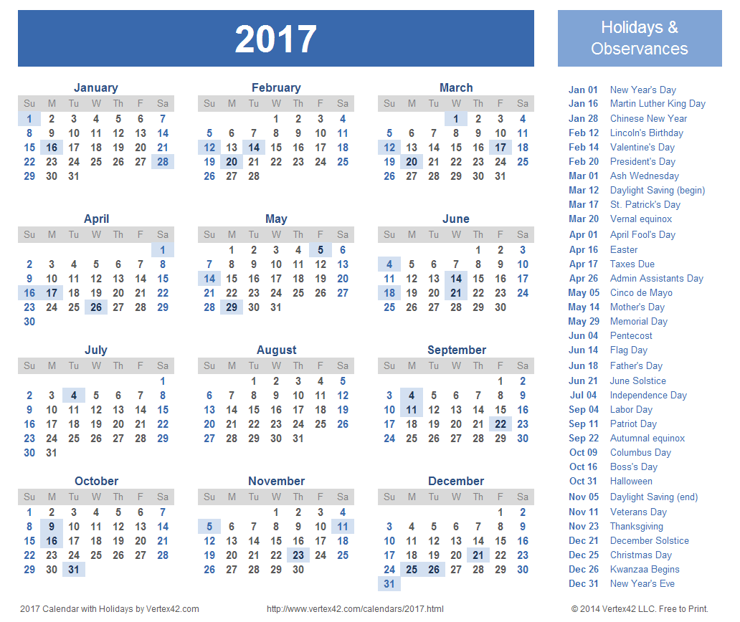2017 Calendar2017

January Event Links **School Health and Safety**

© Graphic by Phillip Martin

|  |
| --- |
| **January 2017 Events** |
| **National Burn Awareness Week (January 31, 2016 to Feb. 6, 2017** <http://burnfund.org/prevention-and-education/burn-awareness-week/>  & <http://www.ameriburn.org/preventionBurnAwareness.php> & **Home fire drill**  [www.homefiredrill.org/](http://www.homefiredrill.org/) |
| **Martin Luther King Day - (3rd Monday in January)**  MLK Day of Service – <http://mlkday.gov/>   About MLK Day of Service <http://mlkday.gov/about/serveonkingday.php>  &  National Service Day <http://www.nationalservice.gov/mlkday> |

**Random Acts of Kindness Calendar**<http://www.randomactsofkindness.org/calendars-and-graphics>

January 2017 Calendar **School Health and Safety**

© Graphic by Phillip Martin

|  |  |  |  |  |  |  |
| --- | --- | --- | --- | --- | --- | --- |
| **Sunday** | **Monday** | **Tuesday** | **Wednesday** | **Thursday** | **Friday** | **Saturday** |
| 01 New Year’s Day | 02 | 03 | 04 | 05 | 06 | 07 |
| 08 | 09 | 10 | 11 | 12 | 13 | 14 |
| 15 | 16 Martin Luther King Day | 17 | 18 | 19 | 20 | 21 |
| 22 | 23 | 24 | 25 | 26 | 27 | 28 |
| 29 | 30 | 31 |  |  |  |  |

Martin Luther King Day (National Service Day)  
<http://www.nationalservice.gov/mlkday>

**Random Acts of Kindness Calendar –**<http://www.randomactsofkindness.org/calendars-and-graphics>

February Event Links **School Health and Safety**

**Random Acts of Kindness Week**

© Graphic by Phillip Martin

|  |
| --- |
| **February 2017 Events** |
| **Random Acts of Kindness Week**  Projects <http://www.randomactsofkindness.org/kindness-project-ideas> |
| **National Burn Awareness Week (February 5-11, 2017)** <http://www.ameriburn.org/preventionBurnAwareness.php> **Home Fire Drills** <http://www.homefiredrill.org/> **Children’s Fire Safety Links** <http://www.burnprevention.org/programs-services/children%E2%80%99s-fire-safety-burn-prevention> |
| **National Eating Disorders Week -** About <http://nedawareness.org/about> |
| **World Thinking Day - Girl Scouts (Every year it is on February 22)** <https://www.girlscouts.org/who_we_are/global/world_thinking_day/> |

**Random Acts of Kindness Calendar –**<http://www.randomactsofkindness.org/calendars-and-graphics>

February 2017 Calendar **School Health and Safety  
  
  
National Burn Prevention Week**

© Graphic by Phillip Martin

|  |  |  |  |  |  |  |
| --- | --- | --- | --- | --- | --- | --- |
| **Sunday** | **Monday** | **Tuesday** | **Wednesday** | **Thursday** | **Friday** | **Saturday** |
|  |  |  | 01 | 02 | 03 | 04 |
| 05 **National Burn Awareness Week** | 06 | 07 | 08 | 09 | 10 | 11 |
| 12 | 13 | 14 | 15 | 16 | 17 | 28 |
| 19 | 20 | 21 | 22 World Thinking Day Girl Scouts | 23 | 24 | 25 |
| 26 | 27 | 28 |  |  |  |  |

**Random Acts of Kindness Week is in February  
  
Random Acts of Kindness Calendar**<http://www.randomactsofkindness.org/calendars-and-graphics> 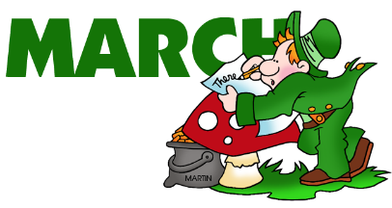March Event Links **School Health and Safety**

**American Red Cross Month  
National Youth Violence Prevention Week   
Learning Disabilities Month**

© Graphic by Phillip Martin

|  |
| --- |
| **March 2017 Events** |
| **American Red Cross Month** <http://www.redcross.org/>  Presidential Proclamation <http://www.redcross.org/news/article/President-Obama-Proclaims-March-Red-Cross-Month> |
| **Brain Injury Awareness Month** <http://www.biausa.org/>  <http://www.biausa.org/brain-injury-awareness-month.htm> 2016 CDC Resources - <http://www.cdc.gov/TraumaticBrainInjury/index.html> |
| **Learning Disabilities Awareness Month** Activates and Information <http://www.ldonline.org/calendar/ld>  Books <http://www.ldonline.org/kids/books> |
| **National Nutrition Month** <http://www.eatright.org/>  About eating right for Kids <http://www.eatright.org/resources/for-kids> |
| **National Poison Prevention Week (March 19-25, 2017)** <http://poisonhelp.hrsa.gov/what-can-you-do/national-poison-prevention-week/participating-in-national-poison-prevention-week/index.html>  Link to the Planning Guide (PDF) |
| **National Native HIV/AIDS Awareness Day (March 20th)** <http://www.nnhaad.org/>  Other HIV/AIDS Awareness Events <http://www.hvtn.org/en/resources/hiv-awareness.html> |
| **National Youth Violence Prevention Week (March 23-27, 2015)**  <http://nationalsave.org/event/national-youth-violence-prevention-week/> |
| **Kick Butts Day (Stop Smoking)**  <http://www.kickbuttsday.org/>  About <http://www.kickbuttsday.org/about/> |

## March Event Links, page 2

|  |
| --- |
| **March 2017 Events** |
| **World Water Day (Every March 22nd)** <http://www.un.org/en/events/waterday/> **About** <http://www.un.org/waterforlifedecade/> |
| **American Diabetes Alert Day (4th Tuesday in March – 2015 March 24)**  <http://ndep.nih.gov/partners-community-organization/diabetes-alert-day/> |

March 2017 Calendar **School Health and Safety  
  
American Red Cross Month**

© Graphic by Phillip Martin

**National brain Injury Awareness Month  
National Youth Violence Prevention Week**

|  |  |  |  |  |  |  |
| --- | --- | --- | --- | --- | --- | --- |
| Sunday | Monday | Tuesday | Wednesday | Thursday | Friday | Saturday |
|  |  |  | 01 | 02 | 03 | 04 |
| 05 | 06 | 07 | 08 | 09 | 10 | 11 |
| 12 | 13 | 14 | 15 | 16 | 17 | 18 |
| 19  National Poison Prevention week | 20 | 21 | 22 World Water Day | 23 | 24 | 25 |
| 26 | 27 | 28  American Diabetes Alert Day | 29 | 30 | 31 |  |

**Random Acts of Kindness Calendar –**<http://www.randomactsofkindness.org/calendars-and-graphics> 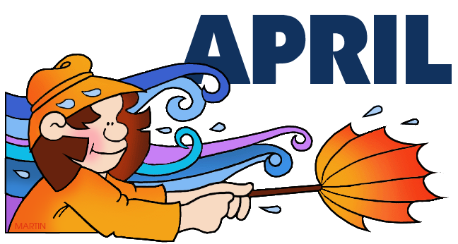April Event Links **School Health and Safety**

**National Child Abuse Prevention Month  
National Sports Safety Month  
National Garden Month  
National Environmental Education Week (15-21)  
National Week of the Ocean   
World Health Day (April 7th)**

© Graphic by Phillip Martin

**Earth Day (April 22nd)**

|  |
| --- |
| **April 2017 Events, page 1** |
|  |
| **School Library Month - Read a New Book Mont**h <http://www.ala.org/aasl/slm>  **National Child Abuse Prevention Month** <https://www.childwelfare.gov/preventing/preventionmonth/>   (2016 information) **& Homeroom Link** <http://www.ed.gov/blog/2014/04/april-is-both-national-child-abuse-prevention-month-and-sexual-assault-awareness-month/> |
| **National Sports Safety Month** <http://www.stopsportsinjuries.org/sports-safety-month.aspx>  **Sports Eye Safety Month April_** <http://www.preventblindness.org/sports-eye-safety>  **Other Eye Health Observances by the month** <http://www.aao.org/newsroom/observances> |
| **Sexual Assault Awareness Month** (SAAM) <http://www.nsvrc.org/saam/sexual-assault-awareness-month-home>  SAAM Resources <http://www.nsvrc.org/saam/resources>  Homeroom Link <http://www.ed.gov/blog/2014/04/april-is-both-national-child-abuse-prevention-month-and-sexual-assault-awareness-month/> Centers fro Disease Control and Prevention (CDC)  <http://www.cdc.gov/features/sexualviolence/> |
| **National Public Health Week (1st week –April 6-12, 2015)** <http://www.nphw.org/about>  & **American Public Health Association Link** <http://www.apha.org/programs/healthweek/> |
|  |

## April Event Links – Page 2 National Week of the Ocean (1st week) School Library Month National Library Week (8-14) International Children's Book Day (1st Wed of April)

|  |
| --- |
| **April 2017 -** |
|  |
| **International Children's Book Day (1st Wed of April)**  <http://globaldimension.org.uk/calendar/event/4690> |
| **National Library Week - April** <http://www.ala.org/conferencesevents/celebrationweeks/natlibraryweek> |
| **School Library Month** <http://www.ala.org/aasl/slm> |
| **Library Events 2016-2017**  <http://www.ala.org/conferencesevents/celebrationweeks> |
| **National Environmental Education Week)** <http://www.eeweek.org/>  About EE Week <http://www.eeweek.org/ee-week>  Facebook Page <https://www.facebook.com/eeweek> |
| **World Health Day (Annually in April)** **WHO Campaign**  <http://www.who.int/campaigns/world-health-day/2014/event/en/>  Background 2014 event  <http://www.cdc.gov/features/worldhealthday2014/> |
| **Earth Day April 22** <http://www.earthday.org/> |
|  |
|  |

****April 2017 Calendar **School Health and Safety  
  
National Child Abuse Prevention Month  
National Sports Safety Month  
School Library Month  
National Library Week (8-14)  
National Environmental Education Week (15-21)  
International Children's Book Day (April 2)**

Columbine Shooting  
April 20, 1999

© Graphic by Phillip Martin

|  |  |  |  |  |  |  |
| --- | --- | --- | --- | --- | --- | --- |
| Sunday | Monday | Tuesday | Wednesday | Thursday | Friday | Saturday |
|  |  |  |  |  |  | 01 April Fool’s Day and International Children's Book Day[2] |
| 02 | 03 **National Youth Violence Prevention Week**  National Public Health Week | 04 World Health Day | 05 | 06 | 07 | 08 |
| 09 | 10 | 11 | 12 | 13 Holocaust Remembrance Day | 14 Good Friday | 15 |
| 16 Easter  & Eastern Orthodox Easter | 17 | 18 | 19 | 20 Take Your Daughter/Son to Work Day &Anniversary of BP Oil Spill | 21 | 22 Earth Day |
| 23    30 | 24 | 25 | 26 | 27  Anniversary of Anne Frank’s Diary being published in English | 28 | 29 |

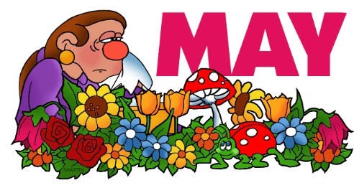May Event Links   
**School Health and Safety**

**National Mental Health Month   
National Physical Fitness and Sports Month  
Building & Safety Month  
International Building Safety Week (1st full week)  
Be Kind to Animals Week (1st full week)  
Bike to Work Week (3rd Week in May)**

© Graphic by Phillip Martin

**Teacher Appreciation Week**

|  |
| --- |
| **May 2017 Events** |
| **National Mental Health Month** & **Mental Health America (link to 2016 information)**  <http://www.mentalhealthamerica.net/may> & **National Suicide Prevention Lifeline** <http://www.suicidepreventionlifeline.org/>  **National Suicide Prevention Lifeline**  **1-800-273-TALK (8255)** |
| **National Physical Fitness and Sports Month** <http://www.fitness.gov/>  & **Let’s Move** <http://www.letsmove.gov/> & **Centers for Disease Control and Prevention** <http://www.cdc.gov/features/physicalactivity/> |
| **Teacher Appreciation Week (scroll down page to May)** <https://www.randomactsofkindness.org/kindness-stories> **Teachers and Parents: A Visual History of Humane education 1880-1945** <http://bekindexhibit.org/for-teachers-and-parents/> **&**  **Grades 1- 5 (Be Kind to Animals Week Grades 1 -5)** <http://bekindexhibit.files.wordpress.com/2012/03/nmas-be-kind-curriculum-1.pdf>  **& Children and Animals** (Canines and Childhood Cancer Project) <http://www.americanhumane.org/children/> **& Be Kind Exhibit** <http://www.museumofanimals.org/#/be-kind/4022591> **& Be Kind to Animals** (Poster contest – check the 2015 deadline this link was for 2014)  http://www.thinkingoutsidethecage.org/site/c.elKWIeOUIhJ6H/b.8922487/k.8F37/Be_Kind_to_Animals_Week_2014.htm |

## May Event Links, page 2

|  |
| --- |
| **May 2013 Events** |
| **School Nurse Day (May 10, 2016)** <http://www.nea.org/grants/31691.htm> (Information about 2016 event) |
|  |
| **National Missing Children’s Day** (May 25th)[3] <http://www.fbi.gov/>  [Example 2016](https://www.fbi.gov/news/stories/2016/may/national-missing-childrens-day-2016/national-missing-childrens-day-2016)  **Amber Alert Program** <http://www.missingkids.com/Amber>   **Building & Safety Month** <http://www.aia.org/advocacy/AIAB098859> |

****May 2017 Calendar  
**School Health and Safety  
  
National Physical Fitness and Sports Month**

**Building and Safety Month  
International Building Safety Week (1st week)  
Be Kind to Animals Week (1st full week)  
Bike to Work Week (3rd Week in May)**

© Graphic by Phillip Martin

|  |  |  |  |  |  |  |
| --- | --- | --- | --- | --- | --- | --- |
| Sunday | Monday | Tuesday | Wednesday | Thursday | Friday | Saturday |
|  | 01 **Be Kind to Animals Week**  **&  Building Safety Week** | 02 | 03 | 04 | 05 | 06 |
| 07 | 08 | 09 | 10 **National**  **School Nurses Day** | 11 | 12 | 13 |
| 14 | 15 | 16 | 17 | 18 | 19 | 20 |
| 21 | 22 | 23 | 24 | 25 **National Missing Children's Day** | 26 | 27 |
| 28 | 29 | 30 | 31 |  |  |  |

**Random Acts of Kindness – Inspiring Resources (Calendars)**  
<https://www.randomactsofkindness.org/inspiring-resources> 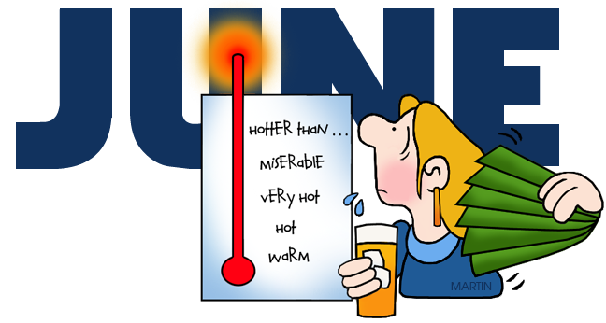June Event Links **School Health and Safety**

**Fireworks Safety Month   
National Home Safety Month**

© Graphic by Phillip Martin

|  |
| --- |
| **June 2017 Events** |
| **Fireworks Safety Month (Begins in June)** <http://fireworkssafety.org/>  & **The National Council in Fire Works**  <http://fireworkssafety.org/> &  **US Fire Administration** <http://www.usfa.fema.gov/citizens/home_fire_prev/holiday-seasonal/summer.shtm>  &  **US Consumer Product Safety Commission** <http://www.cpsc.gov/Safety-Education/Safety-Education-Centers/Fireworks/>  &  **Sparklers Can Burn - Poster** <http://www.cpsc.gov/en/Safety-Education/Neighborhood-Safety-Network/Posters/Sparklers-can-Burn-at-2000-Degrees-Fahrenheit/>  &  **Burn Prevention Network - Summer Information Links** <http://www.burnprevention.org/>  &  **Fire & Burn Safety For Teens (15-19 years)** <http://www.safekids.org/safetytips/field_age/teens-15%E2%80%9319-years>  & **Burn Prevention** <http://www.safekids.org/safetytips/field_age/teens-15–19-years/field_risks/burns-and-scalds>  & **Fire Prevention** <http://www.safekids.org/safetytips/field_age/teens-15–19-years/field_risks/fire>   ***Reference links on page 6, 7 and 8*** |

## June Event Links, page 2

|  |
| --- |
| **June 2015 Events** |
| **National Safety Month** <http://www.nsc.org/nsc_events/Nat_Safe_Month/Pages/home.aspx>  & **Teachers Planet** **– Student Safety Month Lessons Plan Links** <http://www.teacherplanet.com/resource/safetymonth.php> |
| **National Cancer Survivors Day (Sunday June 7th)** American Cancer Society <http://www.cancer.org/cancer/news/specialcoverage/national-cancer-survivors-day>  & <http://www.ncsd.org/>  More resources on page 45 |
| **World Environment Day (June 5th)** <http://www.unep.org/wed/>  & **Example - Many Species (2010 Theme)** <http://www.unep.org/wed/2010/english/theme.asp> & **Sample Graphics for 2014** <http://missingbeatsoflife.blogspot.com/2014/06/happy-environment-day-hd-wallpapers-images.html> |

****June Calendar 2017 **School Health and Safety  
  
Fireworks Safety Month   
National Home Safety Month**

© Graphic by Phillip Martin

|  |  |  |  |  |  |  |
| --- | --- | --- | --- | --- | --- | --- |
| **Sunday** | **Monday** | **Tuesday** | **Wednesday** | **Thursday** | **Friday** | **Saturday** |
|  |  |  |  | 01 | 02 | 03 |
| 04 **National Cancer Survivors Day** | 05 **World Environment Day** | 06 | 07 | 08 | 09 | 10 |
| 11 | 12 | 13 | 14 | 15 | 16 | 17 |
| 18 | 19 | 20 | 21 | 22 | 23 | 24 |
| 25 | 26 | 27 | 28 | 29 | 30 |  |

July Event Links **School Health and Safety**

**Fireworks Safety Month**

© Graphic by Phillip Martin

|  |
| --- |
| **July 2017 Events** |
| **Fireworks Safety Month (Ends in July)** <http://fireworkssafety.org/> |

****July Calendar 2017  **School Health and Safety  
  
Fireworks Safety Month**

© Graphic by Phillip Martin

|  |  |  |  |  |  |  |
| --- | --- | --- | --- | --- | --- | --- |
| **Sunday** | **Monday** | **Tuesday** | **Wednesday** | **Thursday** | **Friday** | **Saturday** |
|  |  |  |  |  |  | 01 |
| 02 | 03 | 04  4th of July | 05 | 06 | 07 | 08 |
| 09 | 10 | 11 | 12 | 13 | 14 | 15 |
| 16 | 17 | 18 | 19 | 20 | 21 | 22 |
| 23 | 24 | 25 | 26 | 27 | 28 | 29 |
| 30 | 31 |  |  |  |  |  |

August Event Links **School Health and Safety**



© Graphic by Phillip Martin

|  |
| --- |
| **August 2013 Events** |
|  |
|  |
|  |
|  |

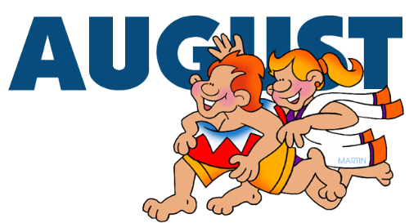August Calendar 2017   
**School Health and Safety**

© Graphic by Phillip Martin

|  |  |  |  |  |  |  |
| --- | --- | --- | --- | --- | --- | --- |
| **Sunday** | **Monday** | **Tuesday** | **Wednesday** | **Thursday** | **Friday** | **Saturday** |
|  |  | 01 | 02 | 03 | 04 | 05 |
| 06 | 07 | 08 | 09 | 10 | 11 | 12 |
| 13 | 14 | 15 | 16 | 17 | 18 | 19 |
| 20 | 21 | 22 | 23 | 24 | 25 | 26 |
| 27 | 28 | 29 | 30 | 31 |  |  |

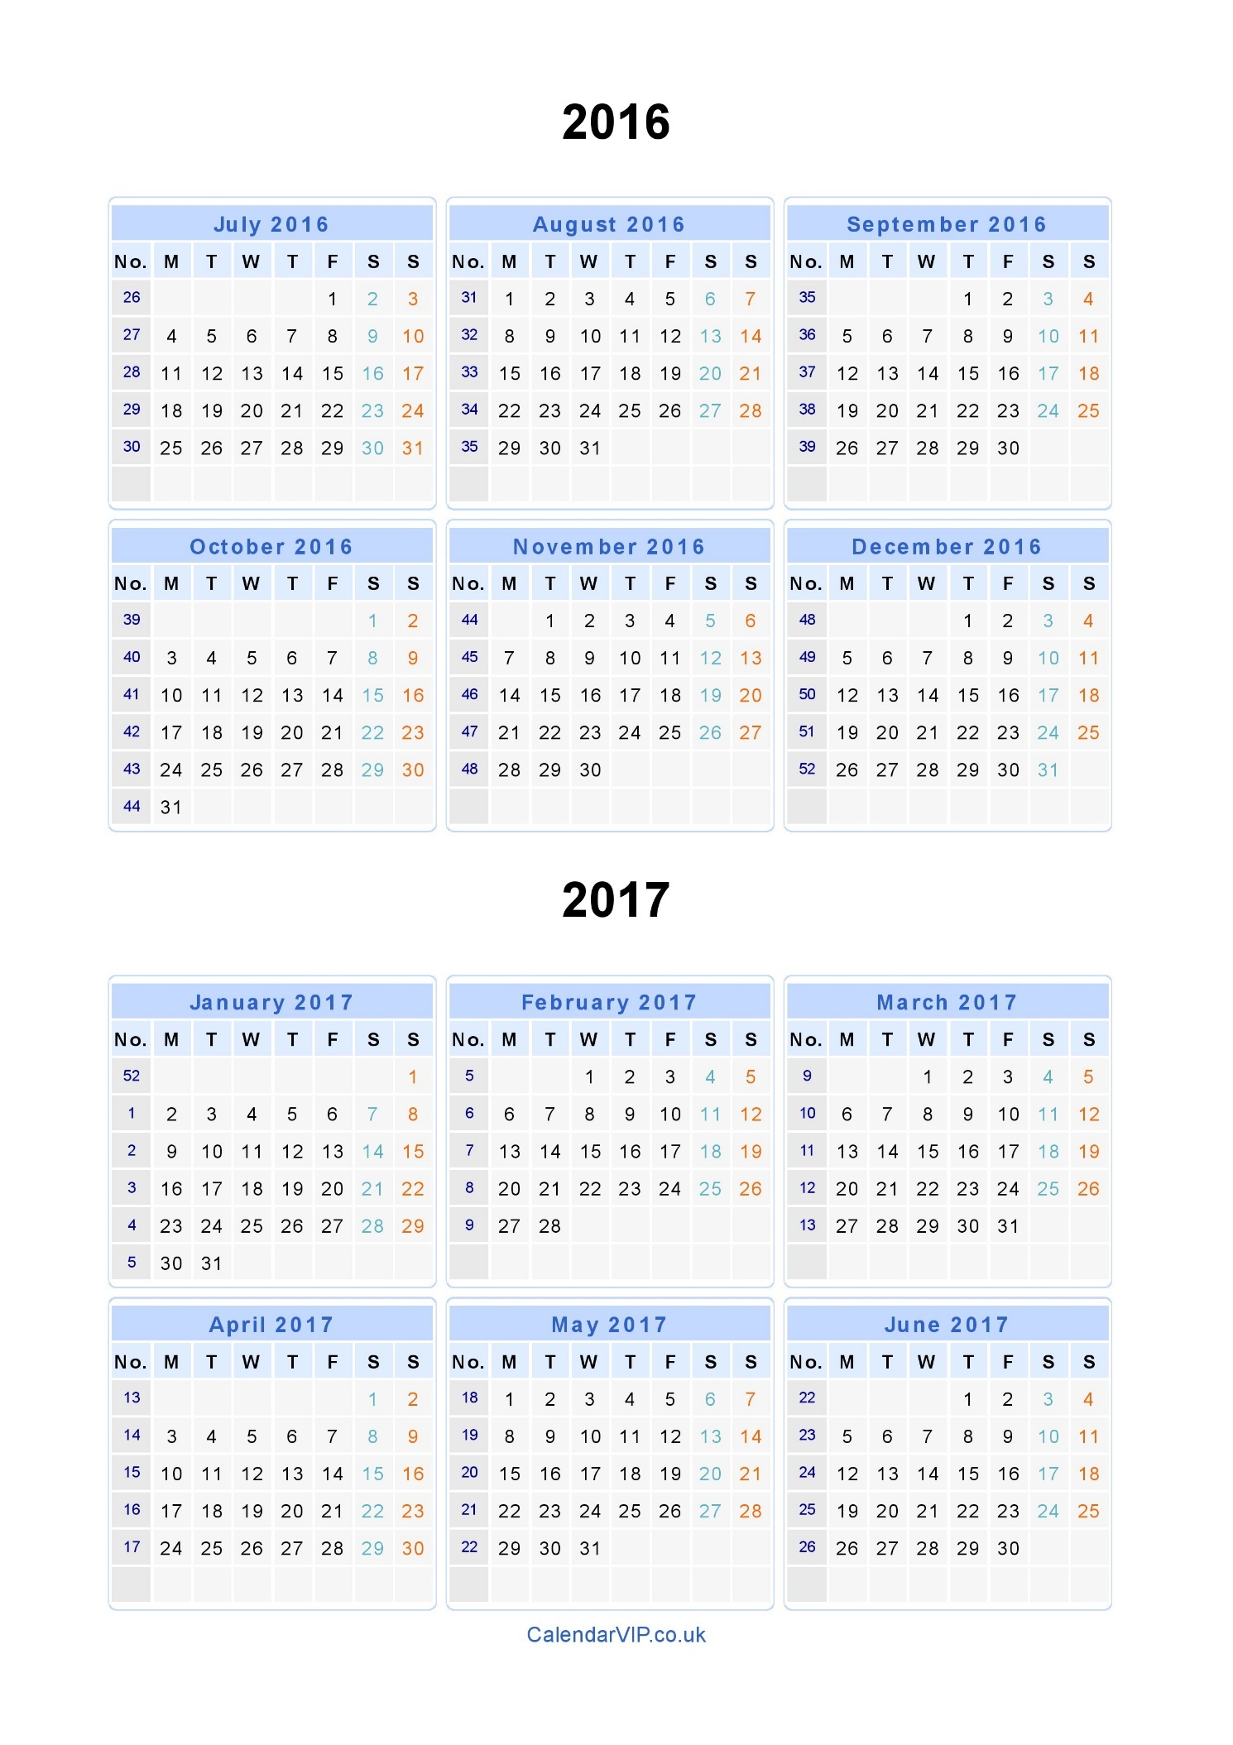

Other Safety Resources

* **Bullying Prevention Books & Web Sites**
  + **Nobody Knew What to Do - A Story about Bullying**  
    by Becky Ray McCain and Illustrated by Todd Leonardo
  + **King of the Playground**  
    by Phyllis Reynolds Naylor and Illustrated by Nola Langer Malone
  + **Say Something**  
     by Peggy Moss and Illustrated by Lea Lyon  
    Author’s web site <http://www.saysomethingnow.com/>
  + **The Recess Queen**  
    By Alexis O’Neill and Illustrated by Laura Huliska-Beith
  + **What Would You Do**by Melisa Haker Ridenour
* **Safety Tips – National Fire Protection Association**  
  <http://www.nfpa.org/safety-information/safety-tip-sheets>
* **Stranger Safety: No-Go-Tell Resources**  
  + Tips to Teach children  
    Safety Education Alliance of America, Inc.  
    <http://www.safetyeducationalliance.com/5-stranger-danger-tips-teach-children/>
  + Free for Kids worksheets and coloring pages  
    <http://www.free-for-kids.com/stranger-danger-worksheets-2.shtml>
  + What to Teach kids about Strangers  
    National Crime Prevention Council  
    <http://www.ncpc.org/topics/violent-crime-and-personal-safety/strangers>
  + My Child Safety Site (Stranger Danger)  
    <http://www.mychildsafety.net/stranger-danger.html>

* + Preschoolers – Elementary schools – Tweens and Teens   
    <http://www.scholastic.com/parents/resources/article/social-emotional-skills/talking-about-stranger-safety>
  + In 5th grade the lesson focuses on internet safety using the website [www.NSTeens.org](http://www.NSTeens.org)
* **Stranger Safety - Books**
  + Who Program, the book “*I Can Play It Safe*” by Author Alison Feigh and Illustrator Laura Logan
    - Videos: Winnie the Pooh: Too Smart for Strangers   
      or Stranger Safety: The Safe Side
  + 3rd and 4th – Focus on being home alone  
    “Would You Do? A Kid’s guide to Staying Safe in a World of Stranger”  
    Author Melissa Haker Ridenour and Illustrator Leslie Fehling is designed to empower children in an non-threatening way
  + *Molly Mouse learns about Stranger Safety[4]”* from the *Pathways to Learning* series to support the *Stranger Danger* Program.  (Ages 5-8)
* **Stranger Safety – Web Sites**
  + Internet Safety (5th Grade)  
    [www.NSTeens.org](http://www.NSTeens.org).
  + Stranger Danger Trainings (K - 2nd Grade)  
    The *Safe Side* also lists other available resources on their website that we will utilize that includes songs, games, and a wrap-up quiz.  [www.thesafeside.com](http://www.thesafeside.com)

Event Links & Resources

* **American Cancer Society - Cancer Survivor’s Day is in June   
  Cancer in Children** <http://www.cancer.org/treatment/survivorshipduringandaftertreatment/storiesofhope/storiesbytopic/index?topic=Cancer%20in%20Children>
* **American Library Association**  
  <http://www.ala.org/conferencesevents/celebrationweeks>
* **Bicycle-Related Injuries**  
  <http://www.cdc.gov/HomeandRecreationalSafety/Bicycle/>
* **Bicycles – Did You Know?**  
  National Highway Traffic Safety Administration  
  <http://www.nhtsa.gov/Bicycles>   
  + **Bicycle Safety Kit** (English and Spanish versions)<http://www.nhtsa.gov/Driving+Safety/Bicycles/Bicycle+Safety+Activity+Kit>
  + **Get to School and Back Game**Game Board, Game Card and Answers<http://www.nhtsa.gov/Driving+Safety/Bicycles/Get+To+School+(and+back+again)+Safely+Gameboard>
* **Bicycle – Safe Routes to Schools**<http://www.saferoutesinfo.org/>
* **Brain Tumors in Young Adults**   
  <http://www.cancer.org/treatment/survivorshipduringandaftertreatment/storiesofhope/storiesbytopic/index?topic=Brain/CNS%20Tumors%20In%20Children>
* **Cancer in Young Adults**  
  <http://www.cancer.org/treatment/survivorshipduringandaftertreatment/storiesofhope/storiesbytopic/index?topic=Cancer%20in%20Young%20Adults>
* **National Safety Council Calendar**  
  <http://www.nsc.org/news_resources/Resources/Pages/NSCSafetyCalendar.aspx>
* **Teachers Planet - Lessons Plans and Resources** <http://www.teacherplanet.com/>

Research Links

.**AAA Foundation for Traffic Safety** <http://www.aaafoundation.org/products/index.cfm?category=schoolbus>

**Moultrie News Online**   
“1923 School Fire gave us fire codes, drills,” by Tom Horton, Jan. 11, 2012.   
(*Dr. Thomas B. Horton is a history teacher at Porter-Gaud School. He lives in the Old Village of Mount Pleasant. See more columns online at www.moultrienews.com.  
 Visit his Web site at* [*www.historyslostmoments.com*](http://www.historyslostmoments.com)*).*

**National Association for Pupil Transportation (NART)** <https://netforum.avectra.com>).

**NCES report**<http://nces.ed.gov/programs/crimeindicators/crimeindicators2010/ind_11.asp>

**Richmond Fire Department, Texas**   
<http://richmondfd.com/WaterSafety.html>

**Stranger Danger**   
The Safe Side web site and videos were created by John Walsh and Julie Clark   
<http://www.thesafeside.com/>

**U.S. Department of Transpiration - Traffic Safety Facts – 2010 Data**  
<http://www-nrd.nhtsa.dot.gov/Pubs/811624.pdf>

**YMCA – Houston, Texas – Youth and Family Program**   
<http://www.ymcahouston.org/youth-family/teen-programs/>

About School Planning   
  
***Safe School Planning©*** is a community of practice movement that creates momentum through networks of individuals who believe that every child attending school learns best when he or she also has a fundamental and profound sense of personal security and wellbeing, safety, confidence and acceptance.

**Our goal is to provide leadership tools that educate and empower all stakeholders of the SSP community:**  students, administrators, educators, school staff, parents, law enforcers, fire fighters, emergency medical (EMS) professionals, doctors, medical staff, dentists, judges, recreation program directors, prosecutors, probation directors, public health educators, mental health leaders and youth-serving professionals to better shape safe learning environments one school at a time.   

The outcome of these collective endeavors is the flourishing of all schools as oases of creativity, engagement, and learning that allows for the fulfillment of the highest ideals of learning, wellbeing and personal achievement.

**Our team believes that a safe school – or any a safe learning environment - is one that is prepared to respond to both the “thinkable and unthinkable crisis or situation”.**We also believe that the two are inextricably linked and more, that   
“there are two types of school administrators: those who have faced a crisis and those who are about to.[5]”   
  
 By learning and practicing what to do about the “thinkable” crises,   
we are able to more effectively handle the “unthinkable”.

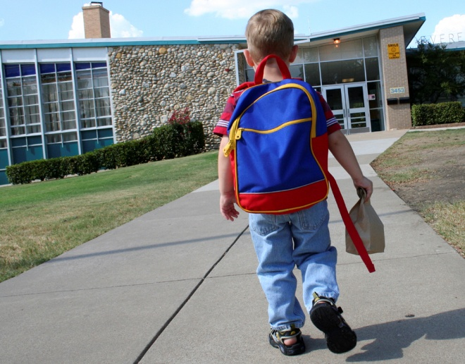**All children deserve to attend safe and secure schools**; yet the frequency and severity of school violence, human-caused incidents and natural disasters is escalating.  Our world is changing and schools can adapt to these changes by demonstrating the leadership to embrace a culture of safety and security.    
  
Thus, **it is time to renew our commitment to safety and the need for access to information that can be used to help all students feel safe within and outside the classroom and to do so with the “best practices” at hand.**

MC900059122[1]

Working Together Supporting   
School Safety  
  
**All children deserve to attend safe and secure schools**; yet the frequency and severity of school violence, human-caused incidents and natural disasters is escalating.  Our world is changing and schools can adapt to these changes by demonstrating the leadership to embrace a culture of safety and security.  Thus, it is time to renew our commitment to safety within and outside the classroom and to do so with the “best practices” at hand.

* **Let’s work together to support school safety** so that all children can be safe so they can learn.
* **Start today by reading Ada Dolch’s book –** *Principles for Principals, Leading the Way to School Safety (Lessons Learned from 9/11).*  Her story is based on lessons learned from her personal experiences during September 11, 2001.

Thank you for all you do every day as you go to school to keep children safe so they can learn.  
  
  
Dolores E. Beaugez  
  
Dolores E. Beaugez, MA – President - Visual Imagry, Inc.   
*Founder of Safe to Learn*  
[dbeaugez@visual-imagry.com  
www.safetolearn.com](mailto:dbeaugez@visual-imagry.comwww.safetolearn.com)

1. Sponsored by National School Transportation Association, NASDPTS, NAPT, PTSI
2. 2 April is Hans Christian Andersen's birthday and since 1967 **International Children's Book Day** has been celebrated on or around this day to inspire a love of reading and to call attention to children's books. <http://globaldimension.org.uk/calendar/event/4690>
3. It falls on May 25 - on that date in 1979, six-year-old New Yorker Ethan Patz disappeared on his way to school. National Missing Children's Day was first observed in 1983.
4. *Molly Mouse learns about Stranger Safety*: Pathways to Learning Activity Book  
   Ages: 5-8. This 16-page activity book helps children deal with issues important to their physical and emotional health. The book features an appealing animal character whose story helps the reader learn about the issue through activities such as word searches, mazes, coloring page, and thought-provoking, open-ended questions. They are sold in packs of 25 activity books of the same style**.**  Order *Molly Mouse learns about Stranger Safety* <http://store.guidance-group.com/Molly-Mouse-Learns-About-Stranger-Safety-Pathways-to-Learning-Activity-Book/productinfo/367279/>
5. Dr. Ronald D. Stephens, NSSC Executive Director, “Safe School Planning: The Art of the Possible.”